**POWER BI ASSIGNMENT-16**

**Topic** – Parameters.

**Exercise** – Create a DAX measure such that data should be showed to the users only if something is searched on the slicer.

Create 4 DAX measure as follows:

Store Setting = IF(ISFILTERED(‘Student Survey’[Store Setting]),SELECTEDVALUE(‘Student Survey’[Store Setting]),”Choose value from the above slicer”)

Sales Toys = IF(HASONEVALUE(‘Student Survey’[Store Setting]), SUM(‘Student Survey’[Toys]), BLANK())

Video Games = IF(HASONEVALUE(‘Student Survey’[Store Setting]),SUM(‘Student Survey’[VideoGames]),BLANK())

Total Amount of Purchase = IF(HASONEVALUE(‘Student Survey’[Store Setting]),SUM(‘Student Survey’[Total Amount of Purchase]),BLANK())

Step – 1. Creating Dashboard as per the visuals given in curriculum.

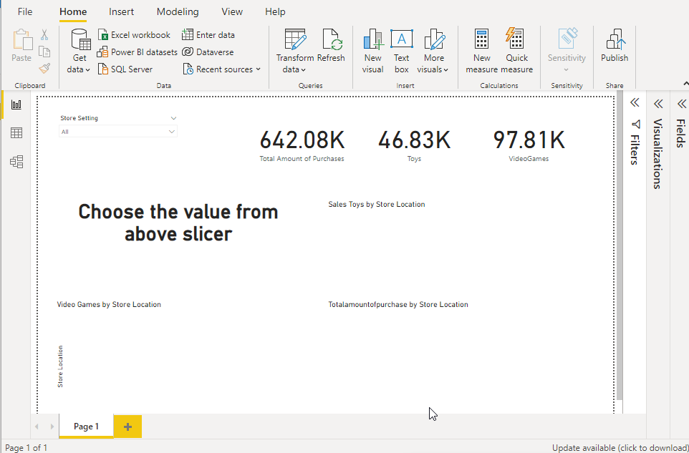

Step – 2. Output if Suburb Store setting is searched on the slicer.

